Procedural Programming Languages

1. Describe what is meant by procedural programming
2. Examples of procedural programming languages
3. Add annotated screenshot
4. Give a brief description of what the code is doing and what language is being used

Object Orientated Languages

1. Describe what is meant by Object Orientated Programming
2. Examples of Object Orientated Programming
3. Add annotated screenshot
4. Give a brief description of what the code is doing and what language is being used

Machine Languages

1. Describe what is meant by Machine Languages
2. Examples of Machine Languages
3. Add annotated screenshot
4. Give a brief description of what the code is doing and what language is being used

Mark-Up Languages

1. Describe what is meant by Mark-Up Languages
2. Examples of Mark-Up Languages
3. Add annotated screenshot
4. Give a brief description of what the code is doing and what language is being used

***Procedural Programming Language***

Procedural programming is breaking down a problem into sections in order to make it easier to solve problems due to them being segmented. The program data is in forms of variables and each function consists of computational thinking statements in order to solve a problem.

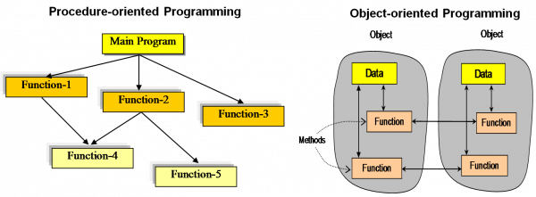An example of Procedural Programming:

Examples of computer procedural languages are BASIC, C, FORTRAN, Java, and Pascal. Procedural languages are some of the common types of programming languages used by script and software programmers. They make use of functions, conditional statements, and variables to create programs that allow a computer to calculate and display a desired output.

***Object Orientated Language***

Object-oriented programming is a programming language paradigm (paradigm is a new method of thinking about a problem or situation). In OPP the code can be broken down and reused in a code where some properties or behaviours may be the same. This can be useful in improving the developer’s ability to quickly prototype software and just increase its life span and functionality since its being updated instead of being constantly remade.

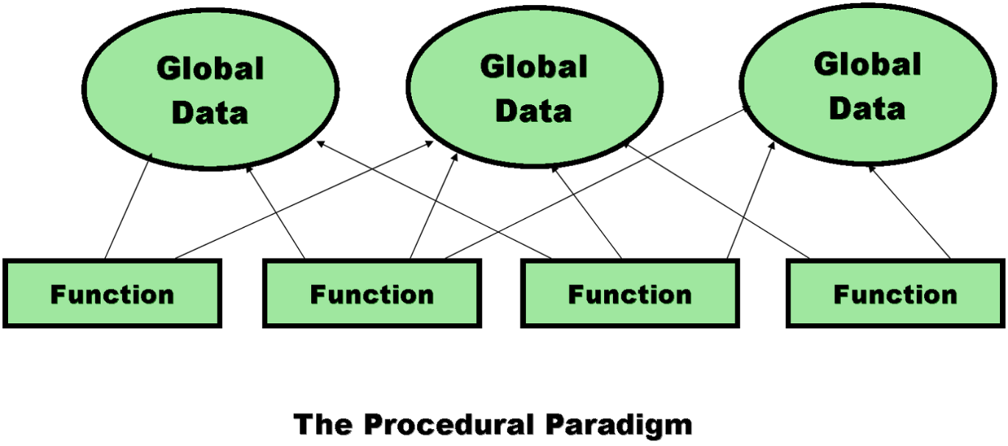An Example of Object Orientated Languages:

Examples of object orientated languages are Java, C#, Python, Ruby, PHP and TypeScript. Object orientated languages are more advanced than procedural orientated programming and is commonly used by web designer for websites or even for databases for banks.

***Machine Language***

Machine Languages is a collection of binary digits or bits that a computer reads and interprets. Machine language is the only language a computer is capable of understanding. Machine language is mostly used for physical hardware for it communicate with each component and let them work together.

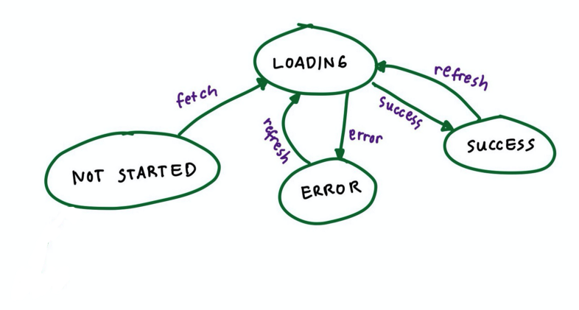An example of Machine Languages:

Examples of Machine Languages are C++, Java, and Virtual Basic. A computer cannot directly understand the programming languages used to create computer programs, so the program code must be compiled. Once a program's code is compiled, the computer can understand it because the program's code is turned into machine language.

***Mark-Up Language***

Mark-Up Language is a computer language that consists of easily understood keywords, names, or tags that help format the overall view of a page and the data it contains.

An example of Mark-Up Language:

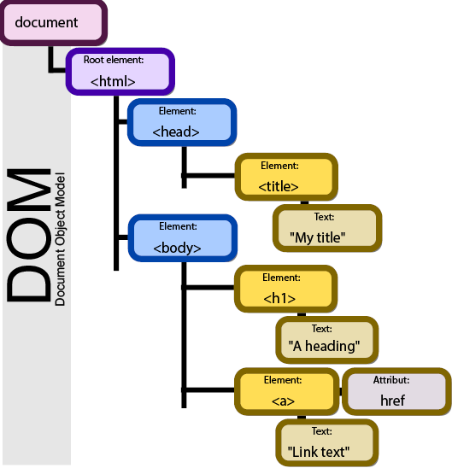

To create any markup language file, any text editor can be used. A markup language is not a programming language. It is special markings, interspersed with plain text, which, if removed or ignored, leave the plain text as a complete whole. Mark-Up is mostly used to create websites that’s why the heavy use of HTML.